Task 1

1. Install CentOS /RHEL

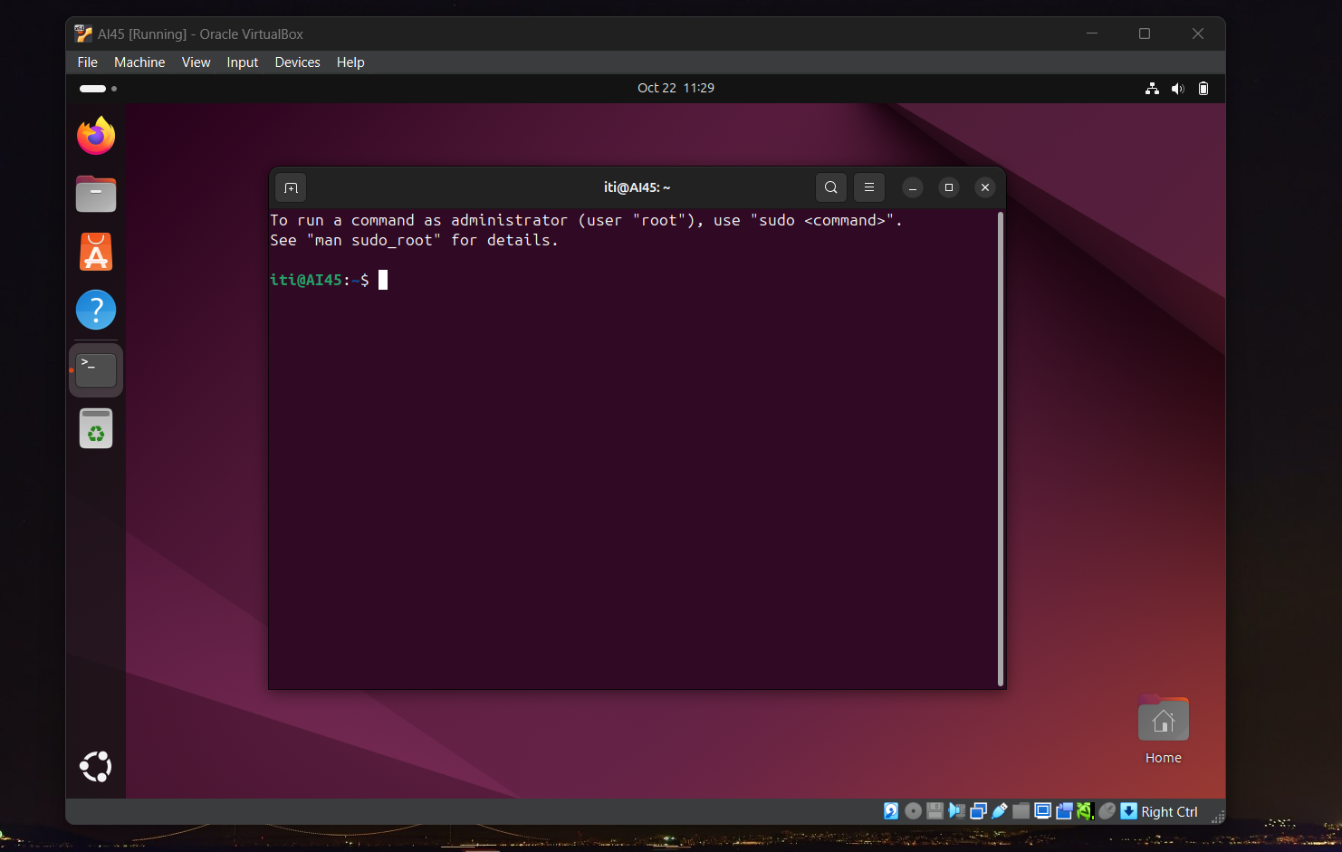

1. What is the difference between cat and more command?

Cat: read file content

More: read file content based screen size

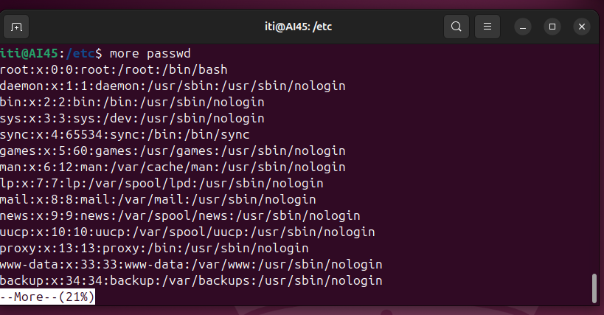



1. What is the difference between rm and rmdir using man?

rm: remove file or directories

rmdir: remove empty directories





1. Create the following hierarchy under your home directory:



a. Remove dir11 in one-step. What did you notice? And how did you overcome that?

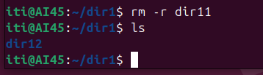

b. Then remove dir12 using rmdir –p command. State what happened to the hierarchy (Note: you are in your home directory).

This command will remove parent and all file inside it   
p stand for parent

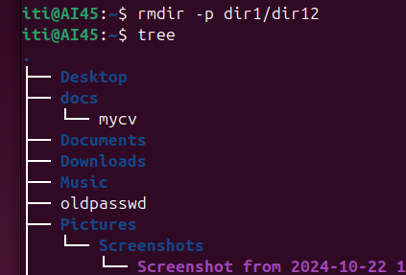

c. The output of the command pwd was /home/user. Write the absolute and relative path for the file mycv

absolute: /home/iti/docs/mycv

relative: docs/mycv

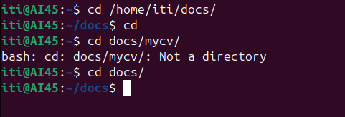

1. Copy the /etc/passwd file to your home directory making its name is mypasswd.

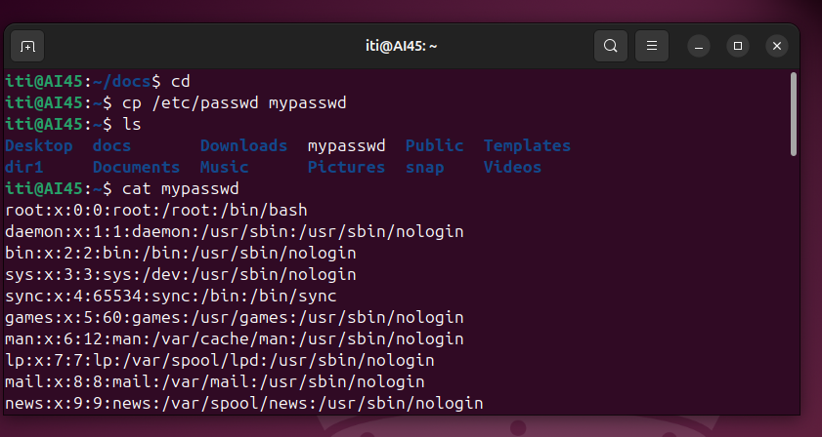

1. Rename this new file to be oldpasswd.

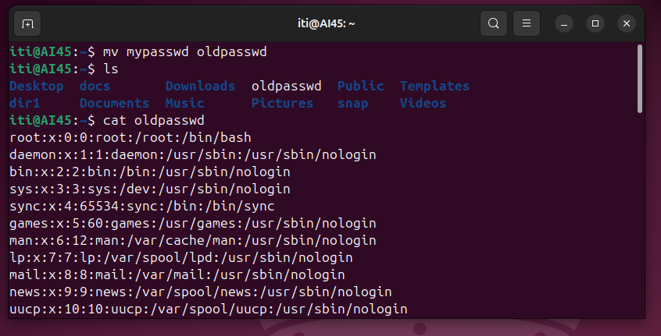

1. You are in /usr/bin, list four ways to go to your home directory

1-cd 2-cd~ 3- cd.. cd.. 4- absolute or relative path



1. List Linux commands in /usr/bin that start with letter w

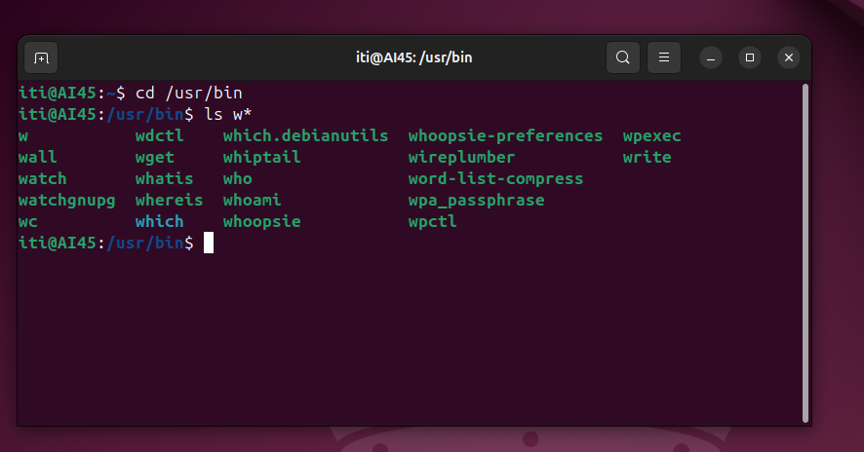

1. Display the first 4 lines of /etc/passwd

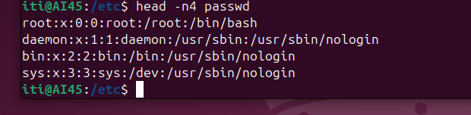

1. Display the last 7 lines of /etc/passwd

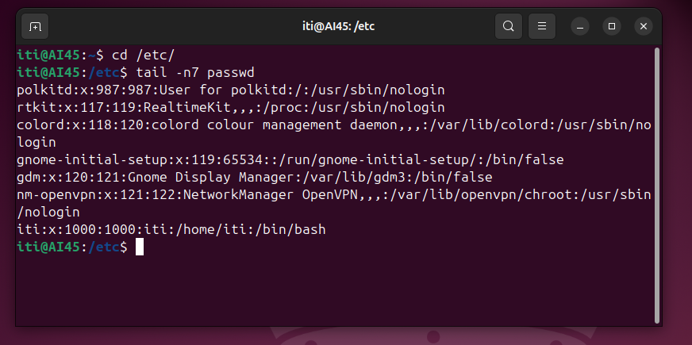

1. Display the man pages of passwd the command and the file sequentially in one command.

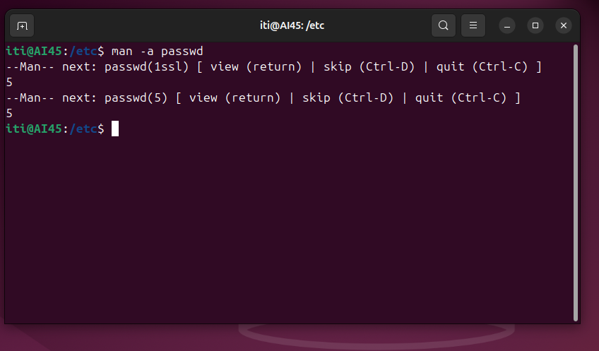

1. Display the man page of the passwd file.

Man passwd

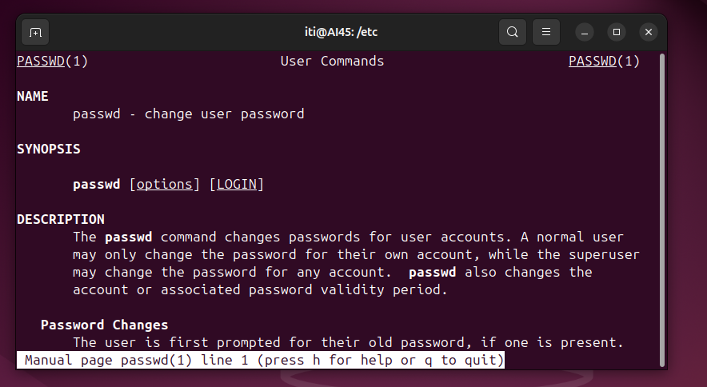

13. Display a list of all the commands that contain the keyword passwd in their man page.

